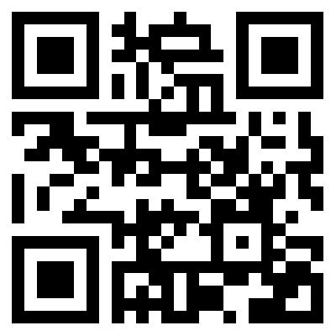**BASIR NAVAB**

325W Adams Blvd. Apt 3144 Los Angeles, CA 90007 (818) 934-3998,

[navab@usc.edu](mailto:navab@usc.edu), my website: **bit.ly/basir_navab**

**EDUCATION**

**University of Southern California, Los Angeles, CA**

Viterbi School of Engineering

Master of Computer Science, Software Engineering - (GPA: 3.07/4) Expected Graduation May 2018

International Academy

Pre-Master (English courses, communication skills - (GPA: 4/4, Top Student +5%) Jun 2016

**Azad University, Tehran, Iran**

Bachelor of Engineering, Computer Science, Software Engineering - (GPA: 3.0/4.0, Top Student +10%) Jun 2015

**TECHNICAL SKILLS (professional):**

**Programming Languages:** JavaScript (Ajax, JQuery), HTML, CSS, Bootstrap, PHP, SQL, C**/**C++/C#,

**Frame works:** AngularJS, Laravel, ASP.NET, Spring MVC

**Applications:** MongoDB**,** MySQL,Oracle Database, Cloud services (AWS, Azure), Postgres + PostGIS, phpMyAdmin, MS Visual Studio (as an IDE), Rational Rose

GitHub, Trello, Jira, Microsoft project plan, Slack

Adobe Photoshop (UI), MS Office

Maple (familiar), CAD (familiar), Matlab (familiar)

**Operating Systems:** Mac, Windows, Linux, Fedora.

**WORK EXPERIENCE**

**Software Engineering Summer Intern**

**Realization of Robotic Systems Lab (USC), Los Angeles, CA** June 2017 – **Present**

* Designed a web application for the USC lab which let lab manager to manage the lab website content dynamically and lab members to manage their profile and adding new content such as their new projects and their papers and so on. (You can see the web application here: cam.usc.edu)
* Used MEAN stack (MongoDB, ExpressJS, AngularJS and Node.js) for developing the lab web application as well as using Yeoman for generating and scaffolding, bower to manage dependencies, CSS, Bootstrap, JQuery and HTML.

**Front-End, Back-End Developer** Jun 2016 – Sep 2016

**Gentle Care Home Health Services, Inc., Los Angeles, CA**

* Monitored their website and different medical applications that were shared among all nurses.
* Implemented a notification application based on mobile texting for sending patient’s information to different nurses. Developed by Laravel frame work with CSS, Bootstrap, HTML and PHP, MySQL

**Front-End, Back-End Developer in Cloud Computing Team** Sep 2014 – Aug 2015

**Amir Kabir University Lab Center, Tehran, Iran**

* Created different secure online payment modules based on the cloud service for three main Iranian banks (Saman, Melat and Pasargad bank). Used ProActive, ASP.net, C#/C++, MySQL.
* Developed various modules on the cloud that compute customer’s text and call services for a mobile operator company named IranCell. Used ProActive, ASP.net, C#/C++, MySQL.

**ACADEMIC PROJECT EXPERIENCE**

**Address Management** Aug 2017 – **Present**

* Developing an amazing idea with my team which let people to change their mailing address once in the website and the website is changing their mailing address anywhere such as Banks, DMV. They don’t need to change their address one by one. This solution saves new movers time and make moving much easier for them than it used to be.
* We will use MEAN stack (MongoDB, ExpressJS, AngularJS and Node.js) as well as using CSS, Bootstrap, JQuery, HTML, Yeoman and AWS services for creating the first prototype.

**University of Southern California, Los Angeles, CA**

**Front-End Developer, Project manager And Life cycle planner** Sep 2016 – May 2017

* Created Farmworker safety application, which notifies farmworkers to take a break when the temperature goes up by texting them. They either can sign up via text or the web application. After launching this project, the rate of dead farmworkers decreased by 40% percentage.
* Developed this web app for both mobile and desktop versions. My team and I used AngularJs, Bootstrap, CSS, HTML for the front End as well as using node.js, npm package, SQL server for the back-end and using AWS services)

**Awards**

* 1nd place at Kharazmi programing competition, a competition between 2009

talented students in Iran, to solve different problems and present efficient ideas.